BUSINESS DEVELOPMENT

**PROJECT**

# Transformation Strategy for SUPPLYSPHERE COMPANY



[This Photo](https://geobrava.geoactivegroup.com/2020/03/how-b2b-marketers-fuel-predictable.html) by Unknown Author is licensed under [CC BY-SA](https://creativecommons.org/licenses/by-sa/3.0/)

1. **Executive Summary**

**Objective:**

Evaluate the current operational performance of SupplySphere and develop a strategic plan for sustained growth across its three primary product categories: office supplies, technology equipment, and office furniture.

**Key Points**

* E-commerce presence: SupplySphere leverages e-commerce as its primary sales channel, capturing a significant share of the online market for office supplies, furniture, and technology products.
* Product diversity: Sales are driven by three key categories—office supplies, technology equipment, and furniture. However, a large portion of revenue still comes from office supplies and technology equipment. Furniture products realized a huge loss in profit compared to previous year despite the increase in revenue.
* Strategic opportunities: There is an immediate need to adjust SupplySphere's strategic focus to capitalize on low profitable product category such as furniture, and optimize marketing and logistics operations.

**Results**

* **Product variety**: Office supplies are contributing heavily to sales volume, but there's limited quantity sold on product categories like furniture and technology.
* **Operational challenges**: SupplySphere is experiencing inefficiencies in its supply chain, leading to higher failure rates in timely deliveries.
* **Campaign effectiveness**: Marketing campaigns have shown inconsistent results, varying significantly in terms of ROI and customer acquisition rates.

1. **Business Model**

SupplySphereoperates as a hybrid B2C (Business-to-Consumer) and B2B (Business-to-Business) company, offering a comprehensive range of office supplies, technology equipment, and office furniture. This dual-market approach allows SupplySphere to serve both individual consumers (e.g., home offices, freelancers) and larger organizations (e.g., businesses, schools, government offices) with tailored solutions.

Target markets:

B2C: Focused on small-scale purchases by individuals and small business owners. The main target market with large sales volume consumed. Products in this segment are typically furniture and technology equipment, which consumers purchase for personal or home office use.

* these are smaller orders, but the frequency of purchases helps maintain consistent cash flow.

B2B: Larger volume orders tailored to corporate. This segment requires bulk purchasing of office supplies, technology, and furniture, often with customized solutions tailored to specific needs.

* Bulk sales and ongoing contracts for organizations, leading to a more predictable revenue stream over time

1. **Analysis**

**1. Total Sales**

$733K total sales with a 20.36% increase. The graph shows a consistent upward trend in sales, with notable peaks towards the end of the year (holiday season: Black Friday, Cyber Monday, etc.)

* increasing demand in key product categories; however, the dip towards the end could indicate **seasonal fluctuations** or a temporary issue such as supply chain challenges or decreased customer demand, but overall, the sales performance is positive and indicates a solid year.

**2. Total profit**

$93K total profit with a 14.24% increase. The graph shows more volatility compared to the sales graph, with sharper spikes and dips. Despite this, it realized improvement in profitability, although not as strong as the increase in sales.

* The fluctuations in profit could suggest **varying profit margins** across different products, even there is loss in profit due to operational costs or logistics or ineffective marketing strategies (huge discounts) that impacted profitability -> a need to focus on **cost efficiency**, possibly by optimizing operational costs or focusing on higher-margin product categories (office supplies, technology products)

Despite November being the highest sales month, the profit in November is notably low, suggesting that SupplySphere ran aggressive discounts or promotions during that period, which boosted sales but reduced the overall profit on each item sold. And this is common issue during major sales events like Black Friday or other holiday promotions, where companies often sacrifice margin to capture higher sales volume and attract new customers

**3. Total sales and total profit by category over 12 months**

a) Total sales

The Technology category consistently has the highest sales across almost all months

-> contribute the most to overall sales volume

There are clear seasonal trends in sales, with major spikes occurring in March, September, October, and November, with November being the highest month for total sales across all categories, suggesting that on Black Friday or Cyber Monday, etc., businesses and consumers are stocking up on technology and supplies due to huge discounts and promotions.

Furniture tends to have the smallest contribution to total sales, as seen in months like Jan, Mar, Aug where it makes up a much smaller portion of the total sales compared to Technology and Office Supplies.

Office Supplies holds a mid-level position in most months, particularly notable in July, where it makes up 51% of the total sales.

b) Total profit

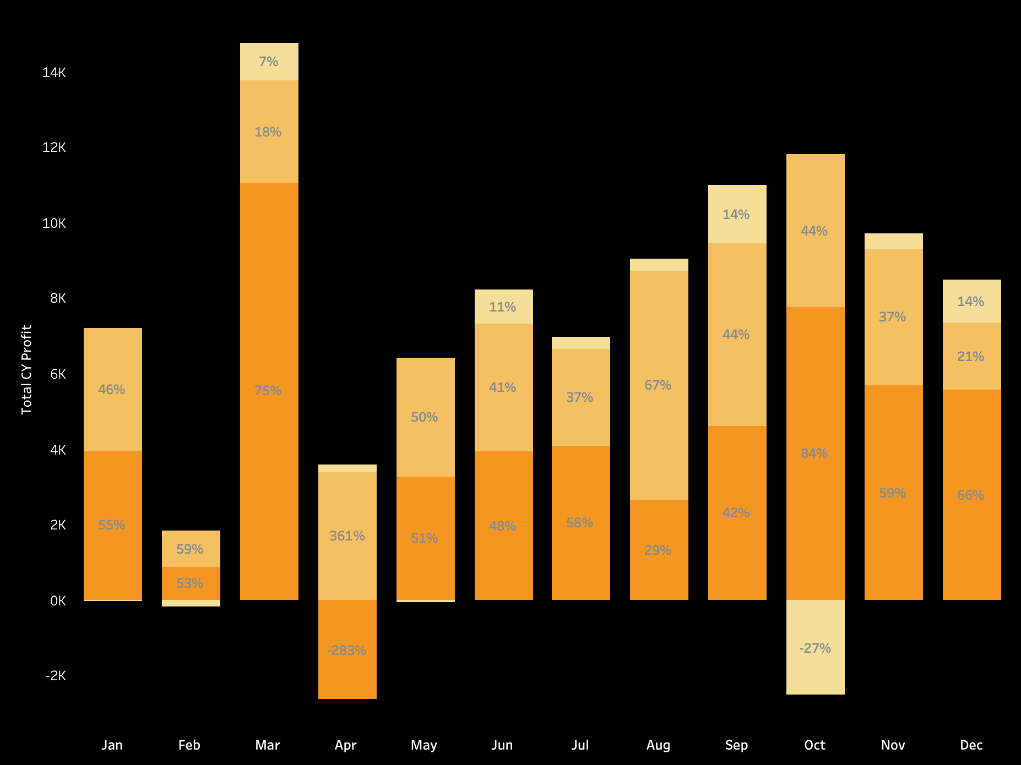

The Technology category (orange) still remains the dominant contributor to profit across most months, particularly in March, May, September, and October (especially in March where it makes up **75%** of total profit) due to effective marketing strategies or low operation costs. However, in April, Technology shows a negative profit of -283%, meaning that Technology sales not only failed to generate profit but likely incurred significant losses; and, October also shows a negative profit for Furniture, with a -27% contribution due to (high returns, discounts, or elevated costs).

**March and September** are the highest profit months, especially due to the strong performance of Technology.

**September** also shows a strong profit performance with Technology contributing 67%, followed by balanced contributions from Office Supplies and Furniture.

Furniture generally contributes the least to total profits, though there are some months where it performs better, such as Sept and Dec, but a significant loss in Oct.

Office Supplies shows erratic performance: it performs well in some months like January, May, and August (holding about 50% or above of the profit in those months), with no losses in profit over the year.

Overall, April and October require deeper investigation to identify the causes of losses, which could range from pricing issues, product returns, or operational inefficiencies in those specific categories (technology products and furniture products).

Furniture:

The dip in total profit in October is the result of the significant loss in profits of sub-categories (Tables and Bookcases) despite their significant contribution to total sales.

On the other hand, chairs (which are the highest-selling and profitable subcategory) likely help the Furniture category remain stable during months when it contributes positively to profits.

Office Supplies:

Binders, Storage, Appliances are key drivers of office supplies’ total sales performance, particularly during the peak months (Aug, Sept, etc.) but those products don’t generate high profits. On the other hand, the Paper subcategory has lower sales, but it generates the highest profit, which was contributing the most to profitability of office supplies category in certain months, helping sustain its profits during current year.

Technology:

Phones are the highest-selling subcategory in Technology, contributing significantly to the sales spikes. Copiers and Accessories also contribute heavily, with strong demand from businesses, especially during budget-spending periods like the end of the fiscal year.

However, Technology shows a notable loss in profit April since Machines (which have negative profit) may have dragged down the category in the underperforming month. Overall, all the sub-categories products in this category have steady profit performance.

* Investigate why Machines underperform and reduce losses.

**4. Sales and Profit distribution by State**

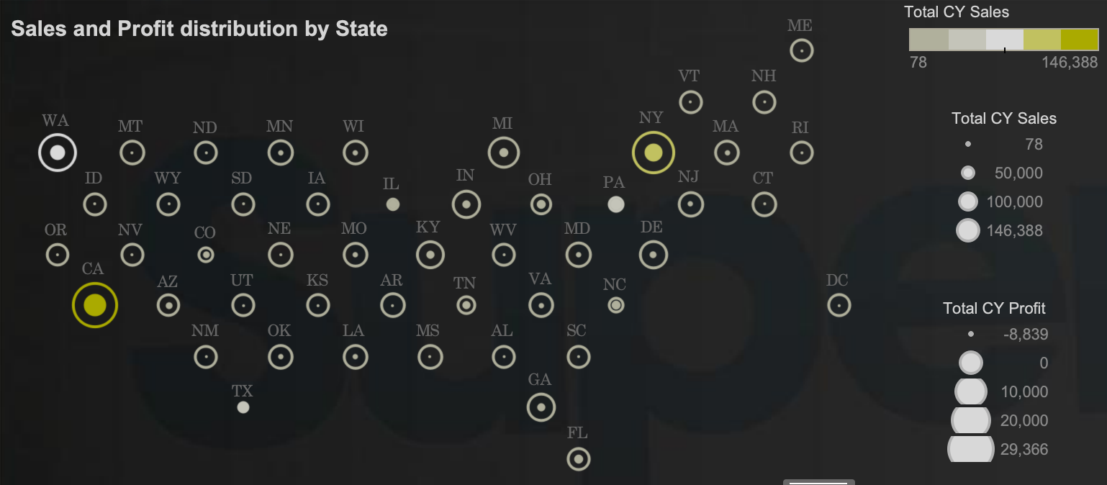

California (CA), New York (NY), and Washington (WA) are clearly highlighted as the top performers in Total Sales. These states are home to large populations, leading to higher demand for products in both B2C and B2B markets. States like California and New York host major urban centers (Los Angeles, San Francisco, New York City) and large corporate hubs, increasing demand for technology, office supplies, and furniture. This demand can also be fueled by the presence of many tech companies and large businesses in these regions. Washington (WA) also stands out in sales, likely benefiting from large tech industry presence in cities like Seattle.

These states also perform well in profitability, with California and New York showing strong profits. However, it’s important to note that there are some states while having high sales, seems to generate relatively lower profits compared to its sales volume, this could indicate lower margins, higher operational costs, or heavy discounting to drive sales in those region because states with high cost of living or intense competition (such as Washington) might have higher operational costs, leading to slimmer profit margins despite high sales figures. The same things also apply for those states with low sales volume but high profits.

* 17 states are performing above the U.S. sales average, driven by strong demand in major economic centers like California (CA), Washington (WA), and New York (NY) due to large populations and high corporate spending.
* 30 states are performing below the U.S. sales average, likely due to smaller populations, fewer large businesses, or less economic activity. Examples include Wyoming, Montana, and North Dakota, which are more rural or less densely populated.
* 33 states are generating above-average profits. Interestingly, 17 of these states have below-average sales but maintain high profits due to operational efficiency or a focus on high-margin products, contributing positively to SupplySphere’s bottom line.
* 14 states are performing below the U.S. profit average. Among them, North Carolina stands out for generating high sales but struggling with profitability due to cost inefficiencies, lower margins, or high operational expenses such as shipping and logistics.

**5. Monthly sales by customer segment**

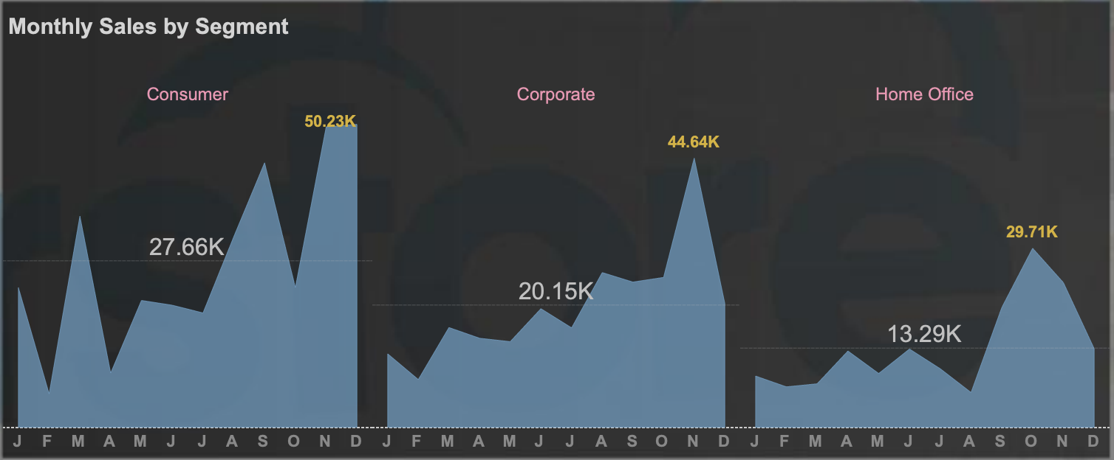

End-of-Year Sales Surge: Across all segments, there is a significant peak in Nov, making it clear that the fourth quarter is the most critical period for sales. Overall, we can see that:

* The Consumer segment contributes the most to total sales, particularly driven by strong peaks in Sept, Nov and Dec (huge drop in Oct)
* The Corporate segment ranks second, providing steady sales throughout the year with significant peaks in Nov but a huge fall in sales in Dec.
* The Home Office segment contributes the least to total sales but shows potential for growth, especially from starting the fourth quarter to Nov (Sept – Nov) with the highest peak in Oct.

Peak Months: The three highest sales months across segments are:

* December (holiday shopping and corporate spending).
* November (Black Friday/Cyber Monday and home office setups).
* September (back-to-school and Q4 preparations).
* Focus its marketing, promotions, and inventory planning around this high-demand period to ensure stock levels, customer outreach, and fulfillment capacity meet the surge in demand.

Addressing First Quarter Slump: The early months of the year (Jan to Apr) still show lower sales performance across segments, suggesting the need for creative promotions or new product launches to drive demand (e.g., “New Year Office Makeovers” or “Spring Productivity Boosters”).

The overall upward trend seen in the chart reflects consistent growth in total sales, which is largely supported by key months where Consumer and Corporate segments peak, especially in Nov. After the strong peak in Nov, a decline in total sales in Dec, which is the result of direct result of early purchasing behavior in corporate and home office segments.

1. **Recommendation**

Both technology and office supplies categories have significant contribution to the overall total sales and total profit as a result of increase in total sales and profits compared to last year. On the other hand, furniture generates lower sales and has negative profits which was dragging down the total profits. Trying to get a deeper understanding of the problem, we figured it out that it is the result of the significant loss in profits of sub-categories Tables and Bookcases.

In office supplies category, paper has good potential for profitability since even though it ranked 3rd in total sales but generating the highest profits; therefore, we should focus on developing marketing strategies to increase sales of paper.

The data suggests that the promotions in November were effective in increasing sales but at the cost of profitability. SupplySphere may want to review its discounting strategy to strike a better balance between driving sales and maintaining healthy profit margins -> offer targeted discounts on select high-margin products or ensuring upsell opportunities to boost overall profitability even during promotional periods.

**There is potential for improvement in managing operational costs or product returns in this category on office supplies**

**Given its smaller contribution, the company may want to evaluate whether it should scale back on furniture offerings or improve cost management in this category.**

**Addressing April's Technology losses and focusing on increasing consistency in Office Supplies and Furniture could help stabilize profitability and ensure better performance across the entire year.**